**YES I AM…** 

To the innocent human with a Golden Heart,    
Yet the epitome of Courageous spirit of her Lioness part.   
To the person who can bear more than one can imagine,   
Yet when she decides to fight back, she can definitely ruin.   
To the symbol of Evolution of the entire Humanity,   
Yet she suffers and bears the unjust social disparity,   
To those who are dignified enough never to say,   
That, ''Men! Admit it, I am superior in every way,   
For you can never Give a Life or bear that Pain,   
But I can Do all that you can n still never complain.''   
To every little soldier oppressed in every little hovel,   
To every little rebel suppressed in every little trial,   
To Each and every Fighter Woman of the entire Human Race,  
I salute and with solemn heart I pray,  
May they have strength to fight this conservative world,  
May they get all the opportunities to strengthen their word,  
I am with all the oppressed women who are fighting,  
Yes, I am a proud educated Woman in Engineering!

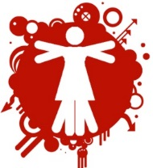

ARUNIMA SHARMA

CSE-1st Year